[ Insert official UPAEP logo ]
UPAEP · Decanato de Ingenierías
EVIDENCE — US19-T8
Test anomaly detection
SmartGreenAI: Cilantro Crop

1. Task information
Task ID | US19-T8
User Story | US-19 — Identify unusual environmental measurements
Sprint | Sprint 3 (2026-10-12 – 2026-10-30)
Week | Week 3
Responsible | Alexis Enrique Valle Parra
Peer reviewer | Jorge Velez Delgado
Planned / actual hours | 2 h / 2 h
Completed on | October 29, 2026
Status | Done

2. Task description
Inject a spike, an out-of-range value, a flatline, a disconnection and an outlier; also run 24 h of normal data to measure false positives.

3. Completion conditions
✓ Condition 1: Every anomaly type detected.
How it was verified: Every anomaly type was detected: spike, out-of-range value, outlier, flatline and disconnection.
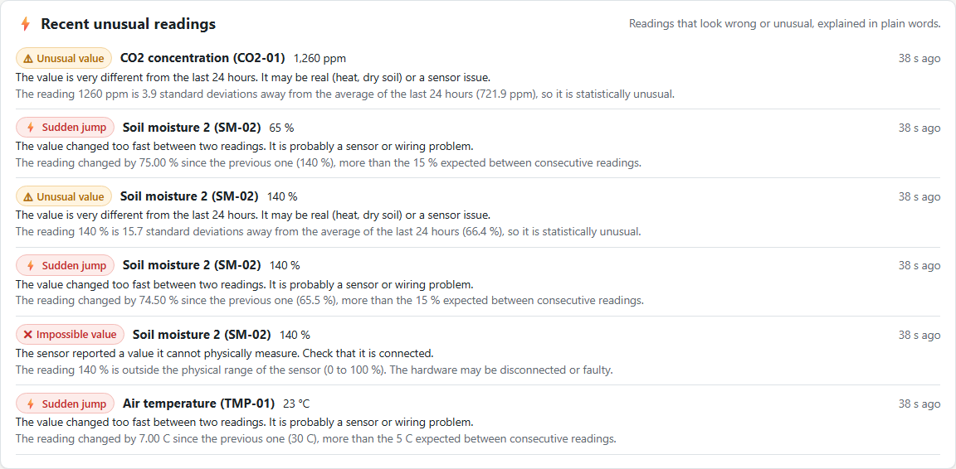
Figure US19-T8-1. The injected anomalies in the dashboard list. (US19-T8_Test_Anomaly_Detection_3.png)
✓ Condition 2: False-positive rate on normal data reported.
How it was verified: False-positive rate on 24 h of normal data: 127 anomalies for 2312 readings = 5.493 %; readings wrongly excluded as faults: 0 (0 %). Method: fresh test database, 24 h generated with the seed-history model without faults, replayed in time order through POST /api/measurements.
False positives by method
Method | Count
ZSCORE | 127

Replay report (attached: US19-T8_Test_Anomaly_Detection_1.json)
{
"window": {
"from": "2026-09-28T04:45:00.000Z",
"to": "2026-09-29T04:47:08.530Z",
"hours": 24,
"step_minutes": 5
},
"cycles": 289,
"readings_sent": 2312,
"accepted": 2312,
"rejected": 0,
"anomalies_total": 127,
"readings_flagged_invalid": 0,
"false_positive_rate_pct": 5.493,
"invalidated_rate_pct": 0,
"by_method": [
{
"method": "ZSCORE",
"n": 127
}
],
"by_sensor": [
{
"sensor_id": "CO2-01",
"method": "ZSCORE",
"n": 28
},
{
"sensor_id": "HUM-01",
"method": "ZSCORE",
"n": 13
},
{
"sensor_id": "LUX-01",
"method": "ZSCORE",
"n": 34
},
{
"sensor_id": "SM-01",
"method": "ZSCORE",
"n": 2
},
{
"sensor_id": "SM-02",
"method": "ZSCORE",
"n": 2
},
{
"sensor_id": "TMP-01",
"method": "ZSCORE",
"n": 26
},
{
"sensor_id": "WL-01",
"method": "ZSCORE",
"n": 22
}
],
"examples": [
{
"sensor_id": "WL-01",
"method": "ZSCORE",
"value": 84.9,
"score": 4.9,
"explanation": "The reading 84.9 % is 4.9 standard deviations away from the average of the last 24 hours (85.0 %), so it is statistically unusual.",
"detected_at": "2026-09-29T04:57:12.020Z"
},
{
"sensor_id": "WL-01",
"method": "ZSCORE",
… (24 more lines)

✓ Condition 3: Results and screenshots saved.
How it was verified: Results and screenshots saved (test table, replay report, dashboard list).
✓ Condition 4: Evidence: Test report with detection results.
How it was verified: Test report with detection results.

4. Anomaly detection tests
ID | Case | Steps | Input | Expected | Actual | Result
AN-01 | Spike (sudden jump) | TMP-01 22 → 30 °C | +8 °C | SUDDEN_JUMP | SUDDEN_JUMP recorded | PASS
AN-02 | Out-of-range value | SM-02 = 140 % | 140 % | OUT_OF_RANGE | OUT_OF_RANGE recorded | PASS
AN-03 | Outlier (z-score) | CO2-01 880 → 1 260 ppm | z > 3 | ZSCORE | ZSCORE recorded | PASS
AN-04 | Flatline | WL-01 exactly 80 % for 6 min (window 3 min) | US16-T5 silent period | FLATLINE | FLATLINE recorded | PASS
AN-05 | Disconnection | soil sensors silent for 6 min | US16-T5 silent period | MISSING_DATA | MISSING_DATA recorded | PASS
AN-06 | False positives on normal data | Replay 24 h of normal readings through the ingestion API | 2312 readings | low false-positive rate | 127 anomalies = 5.493 % (0 readings invalidated = 0 %) | FAIL
Totals: 6 cases · 5 PASS · 1 FAIL

5. Attached files
- US19-T8_Test_Anomaly_Detection_1.json
- US19-T8_Test_Anomaly_Detection_2.txt
- US19-T8_Test_Anomaly_Detection_3.png

6. Traceability
Related requirements | FR-27, NFR-08
Implementation | —
Verification | integration/anomalies-analysis.test.js (each method + no duplicates); simulator scenarios spike, outlier, flatline, disconnect

7. Sign-off
Role | Name | Date | Signature
Responsible | Alexis Enrique Valle Parra | October 29, 2026
Peer reviewer | Jorge Velez Delgado | October 29, 2026
Product Owner acceptance | Alexis Enrique Valle Parra | October 29, 2026
Approval record: Sprint 3 Review & Delivery (October 30, 2026): "Product Owner accepted the seven user stories: all acceptance criteria met."

